https://www.youtube.com/watch?v=pSVk-5WemQ0&list=PLKnIA16_RmvaTbihpo4MtzVm4XOQa0ER0&index=1
00:00 – Intro
02:05 - What is GEN AI?
07:04 - GENAI Impact Areas
11:40 - Is GENAI successful?
17:45 - Reason behind delay
19:40 - The Problem with GENAI
21:00 - Solution
29:28 - Builder's Perspective
35:45 - User's Perspective
41:45 - Should you learn both sides?
44:00 - How to cover GENAI?
46:10 - FAQs and a Promise
1. Introduction
2. What is Generative AI?
Definition (Simplified)
Generative AI is a type of AI that can create new content, such as:
- Text
- Images
- Music
- Videos
- Code
It learns patterns from existing data and mimics human creativity.
Why This Is Important
Earlier AI systems could:
- Predict numbers
- Classify categories
- Recommend items
But they could not create.
Generative AI changed this completely.

3. Evolution of AI → Generative AI (Big Picture)
AI Evolution Path
- Artificial Intelligence
Broad field (rules, logic, expert systems)
- Machine Learning
Learns patterns from data
Examples:
  - Stock price prediction
  - Spam detection
  - Recommendation systems
- Deep Learning
Neural networks
Major breakthroughs in:
  - NLP
  - Computer Vision
- Transformers → Generative AI
Enabled:
  - Language models
  - Image generation
  - Code generation
Key Insight
Generative AI is not separate from AI.
It is the deepest layer of the AI stack. (AI > ML > DL > Gen AI)
📌 This mental model is critical for interviews and system design thinking.

4. What Makes Generative AI Different?
The Biggest Differentiator
Generative AI can:
- Generate new text
- Create original images
- Write production-level code
Earlier belief:
“AI cannot replace human creativity”
Reality today:
Human creativity can be closely mimicked.
This is why Generative AI is considered a breakthrough, not just an improvement.

5. GENAI Impact Areas (Where It Truly Matters)
The speaker highlights four domains where impact is already visible.
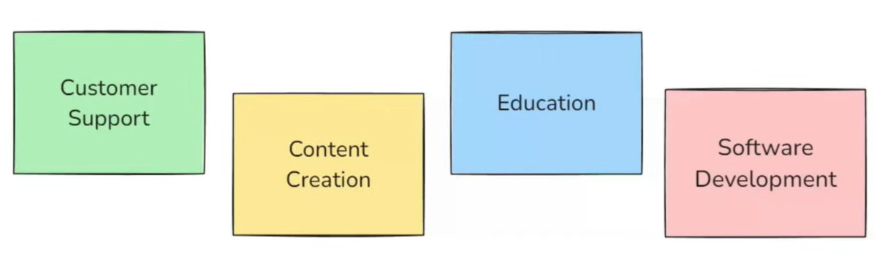

5.1 Customer Support (Major Industry Adoption)
Problem Before
- Large companies received massive customer queries
- Required big call centers
- Very costly and hard to scale
What Changed with GenAI
- First layer: AI chatbot handles common issues
- Second layer: Humans handle complex cases
Industry Perspective (Necessary)
This model is now industry standard:
- E-commerce
- Banking
- Travel
- Food delivery
Companies reduced:
- Cost
- Response time
- Dependency on large support teams
Project Idea (Highly Relevant)
AI Customer Support Chatbot
- Handles FAQs
- Escalates to humans
- Uses conversation memory
📌 Strong beginner-to-intermediate GenAI project
📌 Directly maps to real industry usage

5.2 Content Creation (Creative Industry Shift)
Earlier Belief
Content creation was considered safe from AI.
Reality Now
Generative AI is used for:
- Blogs
- Website content
- Video scripts
- Marketing copy
In many cases, it’s hard to distinguish human vs AI-written content.
Industry Perspective (Necessary)
- Writers are not replaced
- Productivity is multiplied
- AI is used for:
  - Drafting
  - Ideation
  - Rewriting
Humans still:
- Review
- Add creativity
- Maintain brand tone
Project Idea (Relevant)
AI Content Draft Generator
- Blog generation
- Tone control
- Summarization
📌 Useful for marketing + startup use cases

5.3 Education (Mass-Scale Transformation)
What Changed
Learners now have:
- 24/7 personal tutor
- Instant explanations
- Practice questions on demand
Industry Perspective (Very Important)
- EdTech platforms integrate AI tutors
- Corporate training uses GenAI
- Schools are forced to rethink teaching methods
Education is evolving from:
“One-size-fits-all”
to
“Personalized learning”
Project Idea (Strongly Justified)
AI Study Assistant
- Explains concepts
- Generates practice questions
- Creates study plans
📌 High daily-use value
📌 Excellent portfolio project

5.4 Software Development (Developer Productivity Shift)
Traditional Belief
Programming requires deep human creativity.
Current Reality
Generative AI can:
- Write clean code
- Explain logic
- Generate boilerplate
- Refactor code
Industry Perspective (Critical)
- Developers are not removed
- Teams are becoming smaller but more productive
- Focus shifts to:
  - Design
  - Architecture
  - Problem-solving
Project Idea (Optional but Valuable)
Mini AI Coding Assistant
- Code explanation
- Bug reasoning
- Snippet generation
📌 Shows understanding of AI-assisted development

6. Is Generative AI a Successful Technology?
The speaker evaluates success using clear criteria, comparing:
- Internet (successful)
- Crypto/Blockchain (uncertain)
Evaluation Questions
1. Does it solve real-world problems?
✅ Yes (customer support, education, content)
2. Is it useful daily?
✅ Yes (learning, coding, writing)
3. Does it impact the economy?
✅ Yes (global stock market impact from AI models)
4. Does it create new jobs?
✅ Yes
New role: AI Engineer
- Integrates LLMs
- Builds GenAI systems
- Adds safety & guardrails
Demand is increasing steadily.
5. Is it accessible?
✅ Yes
No coding required to use basic tools.
Conclusion
Generative AI is closer to the “Internet path”, not the crypto path.
📌 Investing time in GenAI is strategically correct.

Final Takeaway for Video 1
This video is about building conviction and clarity, not tools.
You should walk away with:
- Clear mental model of GenAI
- Confidence that it’s industry-relevant
- Understanding why structured learning is required

7. The Core Problem with Generative AI
Generative AI is evolving at an extremely fast pace. New models, tools, techniques, and research papers are released almost daily. Because of this speed, two major problems arise.
7.1 Information Overload
It has become very difficult to:
- Track all GenAI advancements
- Understand which developments are important
- Extract meaningful learning from massive information
Learners often feel overwhelmed because there is too much content and no clear structure.
7.2 Noise and FOMO Environment
Another serious issue is noise created by social media and online platforms.
Many people constantly create fear-driven narratives like:
- “If you don’t learn GenAI now, you will be left behind”
- “This new tool has changed everything”
This leads to:
- Confusion
- Loss of motivation
- Random learning without direction
7.3 No Single Structured Learning Source
Because Generative AI is a new technology:
- There is no single, universally accepted curriculum
- Content is scattered across blogs, videos, and tools
- Everyone teaches it differently
Core Problem Summary
The real problem is not learning GenAI, but:
Designing a clear and structured curriculum for GenAI.

8. Solution: Creating a Mental Model for GenAI
To solve this confusion, the instructor decided to create a mental model (framework).
8.1 Purpose of the Mental Model
The mental model helps to:
- Reduce information overload
- Organize GenAI concepts logically
- Design a clean curriculum
The model is built using:
- AI experience
- Machine Learning knowledge
- Deep Learning understanding

9. Foundation Models: The Center of Generative AI
After analyzing GenAI deeply, the instructor identifies one central concept.
9.1 What Are Foundation Models?
Foundation Models are:
- Very large-scale AI models
- Trained on massive datasets (almost internet-scale)
- Trained using huge computational resources (many GPUs)
- Extremely expensive to train
9.2 Key Property: Generalization
Unlike traditional ML models, foundation models are general-purpose models.
Traditional ML Models
- Task-specific
- Example:
  - Stock price prediction model
  - Only predicts stock prices
  - Cannot perform other tasks
Foundation Models
- Can solve multiple tasks
- Examples:
  - Text generation
  - Sentiment analysis
  - Summarization
  - Question answering
Intuition Example
Training a foundation model is like:
Giving a very intelligent person access to millions of books across all domains.
Such a person can solve problems across multiple fields.

9.3 Large Language Models (LLMs) as Foundation Models
The most common example of foundation models today is:
Large Language Models (LLMs)
LLMs are the backbone of Generative AI.
Because they are trained on:
- Massive text data
- Large model architectures
- Huge parameter counts
They learn not only:
- Next-word prediction
but also:
- Sentiment understanding
- Reasoning patterns
- Question answering

9.4 Beyond Text: Large Multimodal Models (LMMs)
Foundation models are not limited to text.
They also include:
- Image models
- Audio models
- Video models
These are called Large Multimodal Models (LMMs).
Examples:
- Text + Image
- Text + Audio
- Text + Video
That is why the instructor uses the term Foundation Models, not just LLMs.

10. Two Perspectives of Generative AI
Using foundation models as the center, the entire GenAI field can be divided into two perspectives.
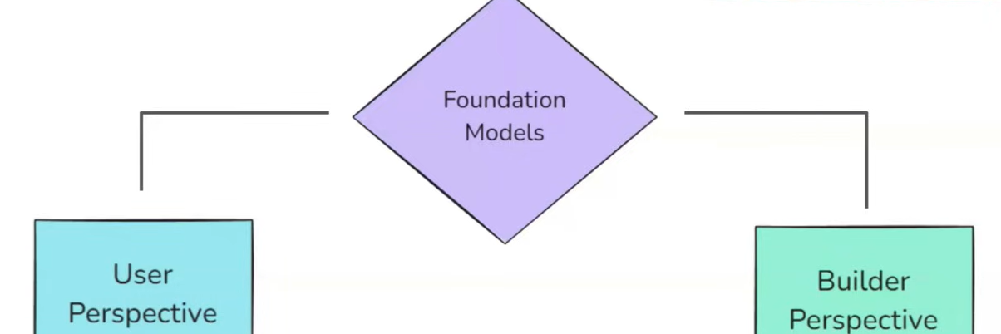
10.1 User Perspective
In this perspective:
- You use existing foundation models
- You build applications using them
Examples:
- Chatbots
- AI assistants
- Enterprise AI tools
10.2 Builder Perspective
In this perspective:
- You build foundation models
- You train, optimize, and deploy them at scale
Examples:
- Training LLMs
- Optimizing model performance
- Deploying models globally
Core Insight
Every GenAI concept belongs to:
- User perspective
- Builder perspective
- Or both
This single idea simplifies the entire GenAI landscape.

11. Classifying GenAI Terms Using the Mental Model
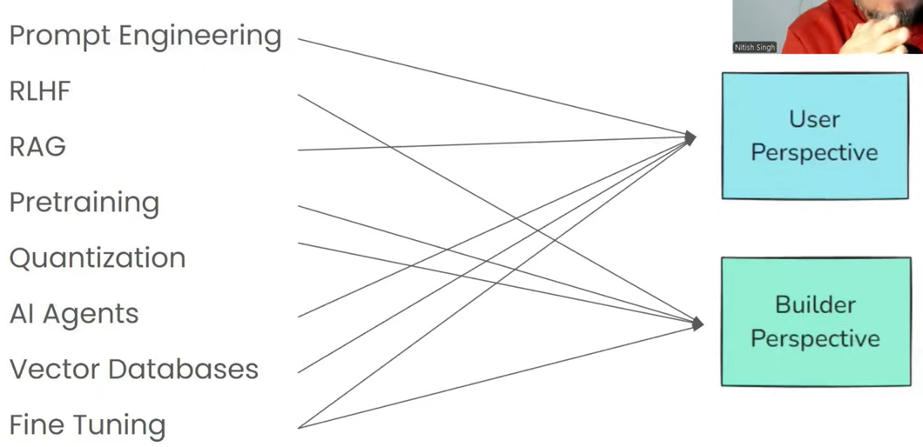
11.1 User-Side Concepts
These involve using pre-built LLMs.
Prompt Engineering
- Writing better inputs (prompts) for LLMs
- Improves output quality
- Uses an already-built model
➡️ Belongs to User Perspective
RAG (Retrieval-Augmented Generation)
- Connecting LLMs with private data
- Example: Asking questions on company documents
➡️ Belongs to User Perspective
AI Agents
- LLM + tools
- Can perform actions, not just answer questions
- Example: Booking tickets automatically
➡️ Belongs to User Perspective
Vector Databases
- Used to store embeddings in RAG systems
➡️ Belongs to User Perspective

11.2 Builder-Side Concepts
These are used while building LLMs.
Pre-training
- Training a foundation model on massive data
- Requires large hardware and infrastructure
➡️ Builder Perspective
RLHF (Reinforcement Learning with Human Feedback)
- Modifies LLM behavior
- Improves safety and alignment
➡️ Builder Perspective
Quantization
- Optimizing models for faster inference
- Reduces hardware requirements
➡️ Builder Perspective

11.3 Concepts Belonging to Both Sides
Fine-tuning
- Builder side: Deep-level fine-tuning
- User side: Shallow or task-specific fine-tuning
➡️ Both Perspectives

13. Builder’s Perspective: Curriculum Overview
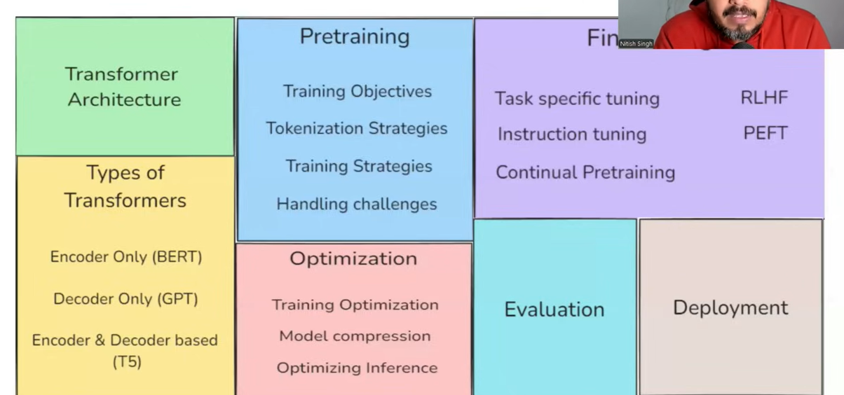
This side focuses on building and deploying foundation models.
13.1 Prerequisites
To learn this side, you must know:
- Machine Learning fundamentals
- Deep Learning fundamentals
- A deep learning framework:
  - PyTorch (preferred)
  - TensorFlow

13.2 Core Curriculum (Builder Side)
Step 1: Transformer Architecture
You must understand:
- Encoder
- Decoder
- Embeddings
- Self-attention
- Layer normalization
- Language modeling
Step 2: Types of Transformers
- Encoder-only (BERT)
- Decoder-only (GPT)
- Encoder-decoder models
Step 3: Pre-training
Includes:
- Training objectives
- Tokenization strategies
- Distributed training
- Training challenges
- Evaluation during training
Step 4: Optimization
- Quantization
- Knowledge distillation
- Inference optimization
Step 5: Fine-tuning
- Task-specific tuning
- Instruction tuning
- Continual pre-training
- RLHF
- PEFT techniques
Step 6: Evaluation
- Metrics
- Benchmarks
- Leaderboards
Step 7: Deployment
- Model serving
- Scalability
- Production readiness

Industry Perspective (Builder Side – Necessary)
Builder-side work is mostly done by:
- Big tech companies
- AI research labs
Reason:
- Huge data requirements
- Massive GPU costs
- Complex infrastructure
This explains why most learners should focus more on the user side first.

14. User’s Perspective: Curriculum Overview
This side focuses on building applications using foundation models.
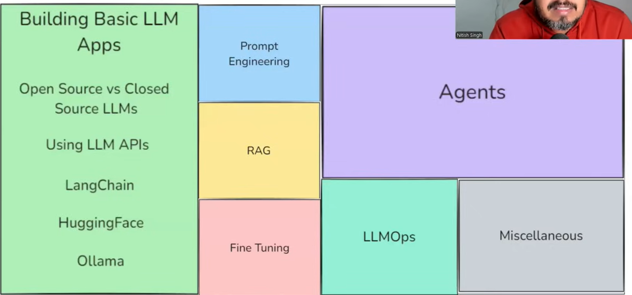
14.1 Using LLMs
- Closed-source models via APIs
- Open-source models locally
- Tools like Hugging Face, Ollama
14.2 Improving LLM Output
Three major techniques:
Prompt Engineering
- Improves output using better inputs
RAG
- Enables private data usage
Fine-tuning
- Task-specific customization

14.3 AI Agents
Difference:
- Chatbot → answers questions
- AI Agent → performs actions using tools
Example:
- Travel booking agent
- Task automation system

14.4 LLMOps
LLMOps includes:
- Deployment
- Monitoring
- Evaluation
- Continuous improvement
It is similar to DevOps but for LLM-based systems.

14.5 Multimodal and Miscellaneous Topics
Includes:
- Image generation (e.g., diffusion models)
- Audio models
- Video models

Industry Perspective (User Side – Necessary)
Most real-world GenAI applications today are:
- User-side systems
- Built using pre-trained foundation models
- Deployed as products and services
This is where most jobs and projects exist today.

Project Ideas
User-Side (Highly Recommended)
- RAG-based document Q&A system
- AI agent for task automation
- AI study assistant
- Enterprise knowledge assistant
Builder-Side (Optional / Advanced)
- Fine-tuning open-source LLMs
- Implementing quantization
- Mini transformer implementation

Final Takeaway from This Chunk
Generative AI can be fully understood using one simple framework:
- Foundation Models at the center
- Two perspectives:
  - Builder
  - User
Every tool, term, and technique fits into this model.
Once you understand this, GenAI stops feeling chaotic.

15. Should You Learn Both Builder and User Sides?
15.1 Clear Separation of Roles
The instructor clearly explains that Builder side and User side correspond to different professional roles.
Builder Side (Who does this?)
- Research Scientists
- Data Scientists
- ML Engineers (with strong MLOps skills)
What they do
- Build foundation models
- Train large-scale LLMs
- Deploy models at scale
- Optimize performance and cost
This side requires:
- Strong ML & Deep Learning
- Infrastructure knowledge
- High computational resources

User Side (Who does this?)
- Software Developers
- Backend / Full-stack Engineers
- AI Engineers
What they do
- Use pre-trained LLMs
- Build real-world applications
- Integrate LLMs via APIs
- Solve business problems
Key Insight
If you know basic software development, you can already do:
80–85% of user-side GenAI work
This explains why:
- LLM-based apps are growing rapidly
- Entry barrier is lower on the user side

15.2 Why Knowing Both Sides Is Powerful
The instructor emphasizes that the best GenAI engineers understand both sides, even if they don’t work deeply on both.
Why builder-side knowledge helps user-side work
If you understand:
- How foundation models are trained
- Their limitations
- Their failure modes
Then you can:
- Design better prompts
- Choose correct architectures
- Debug model behavior effectively
📌 This makes you far better than someone who only “uses APIs blindly.”

15.3 Salary and Career Perspective (Industry Reality)
Industry Truth
- A pure software developer can build AI apps
- But someone with both builder + user knowledge:
  - Has stronger system-level thinking
  - Commands higher salaries
  - Fits the AI Engineer role better
Career Mapping
- Want to be a Research Scientist → Focus more on Builder side
- Want to build AI products → Focus more on User side
- Want to be an AI Engineer → Learn both in parallel
👉 This answers the question:
Yes, learning both sides is beneficial — but depth depends on your goal.

16. How to Cover Generative AI (Learning Strategy)
16.1 Parallel Learning Approach
Instead of:
- Completing builder side fully
- Then starting user side
The instructor proposes:
Cover both sides in parallel
Why?
- Very little overlap
- Keeps motivation high
- Improves conceptual understanding

16.2 Builder Side Coverage Plan
The builder side is broken into small, focused modules instead of one huge playlist.
Planned Builder Modules
- Transformer Architecture (already covered in DL playlist)
- Encoder-only Transformers
- Decoder-only Transformers (GPT)
- Encoder–Decoder Transformers
- Pre-training
- Fine-tuning
- Deployment
Key Design Decision
Instead of:
- One massive playlist (low commitment, overwhelming)
The plan is:
- Multiple small, dedicated playlists
- Each covering one focused concept
📌 This reduces learner burnout and improves retention.

16.3 User Side Coverage Plan
The same modular approach is applied here.
Planned User Modules
- Building basic LLM applications
- Prompt Engineering
- RAG
- Fine-tuning (from user perspective)
- Advanced GenAI applications
The first focus is:
Building basic LLM-based applications
This aligns perfectly with industry needs, where most GenAI jobs exist.

Project Insight
At this stage, the most appropriate project focus is user-side, not builder-side.
Recommended Focus
- LLM-based applications
- RAG systems
- AI agents
Builder-side projects are:
- Advanced
- Optional
- More research-oriented
📌 This matches real hiring trends.

